Title: Data Preprocessing and feature engineering in machine learning.
Aim: To understand & implement various data preprocessing and feature engineering techniques using Python for machine learning applications.

Batch: 1
Roll No.: 16010123012
Experiment / Assignment / Tutorial No.: 1

Expected Outcome of Experiment:
CO1: To establish a strong foundation in machine learning fundamentals.

Books/ Journals/ Websites referred:
- https://www.python.org/about/
- https://www.upgrad.com/blog/data-preprocessing-in-machine-learning/
- https://towardsdatascience.com/data-preprocessing-concepts-fa946d11c825
- Data Mining: Concepts and Techniques by Jiawei Han, Micheline Kamber, Jian Pei

Introduction
What is a feature and why do we need the engineering of it? Basically, all machine learning algorithms use some input data to create outputs. This input data comprise features, which are usually in the form of structured columns. Algorithms require features with some specific characteristics to work properly. Here, the need for feature engineering arises. Feature engineering efforts mainly have two goals:
  - Preparing the proper input dataset which is compatible with the machine learning algorithm requirements.
  - Improving the performance of machine learning models.

Different Preprocessing Techniques:
- Imputation
- Handling Outliers
- Binning
- Log Transform
- One-Hot Encoding
- Grouping Operations
- Feature Split
- Scaling

** For a given dataset (housing.csv), implement the above preprocessing techniques, explain & attach the necessary snapshots for function/library used.

1. Imputation
Imputing is the process of filling in missing data in a dataset. There are several techniques for imputing missing values in a dataset, such as mean imputation, median imputation, mode imputation, and KNN imputation.
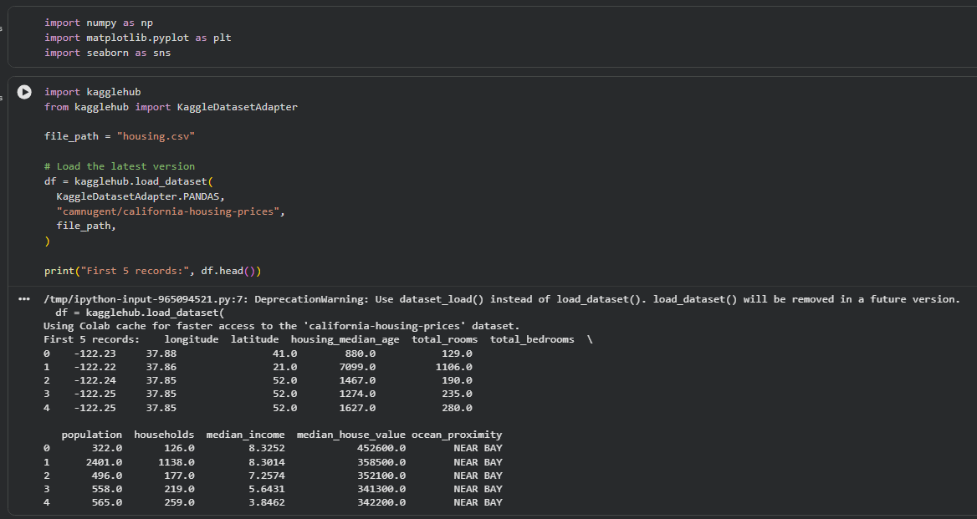
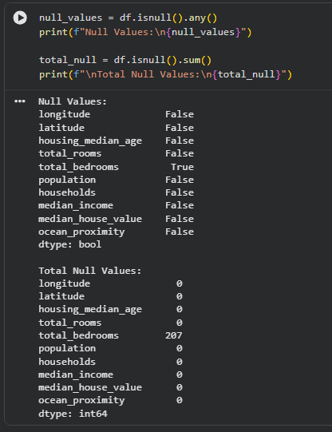
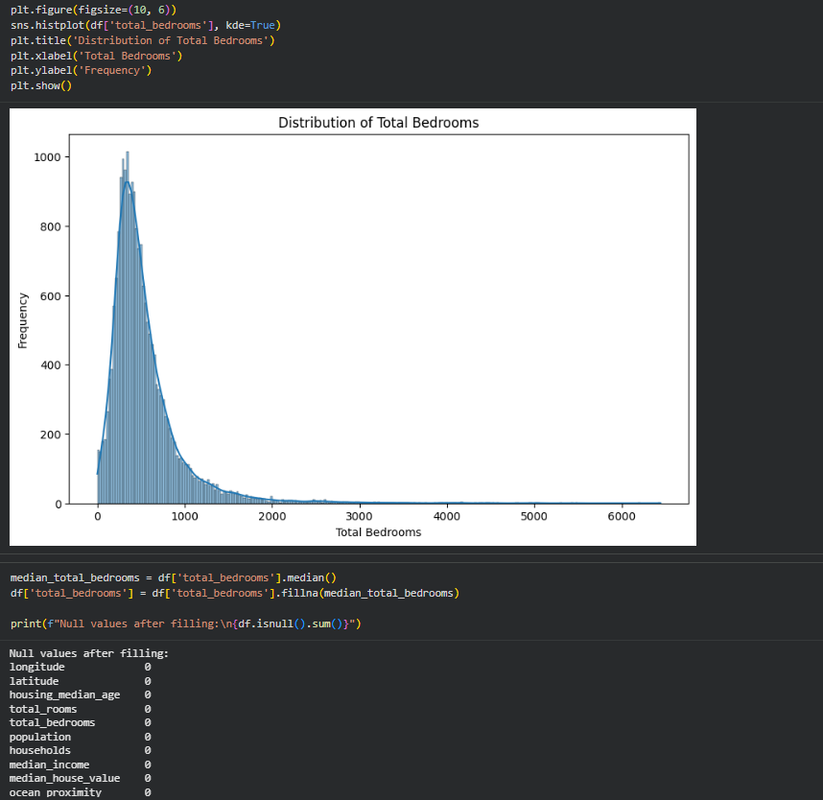

2. Handling Outliers
Handling outliers is a data pre-processing technique that involves identifying and dealing with data points that are significantly different from the rest of the dataset. Outliers can occur due to measurement errors, data entry errors, or simply because they represent extreme values. Handling outliers is important because they can skew the results of data analysis and machine learning models. There are several techniques for handling outliers, including removing them, Winsorizing the data, transforming the data, or leaving them as is and using robust statistical methods that are less sensitive to outliers. The specific technique used will depend on the nature of the data and the goals of the analysis.
Visualize the data: Before you can handle outliers, you need to identify them. One way to do this is by visualizing the data using box plots, histograms, or scatter plots. Outliers are typically data points that are far away from the rest of the data, so they will be visible as points that are outside the range of the majority of the data.
Remove outliers: If you have a small number of outliers in your dataset, you can consider removing them. One way to do this is by using the Z-score method. You can
calculate the Z-score for each data point, and remove any data point that has a Z-score greater than a certain threshold (e.g. 3). Here's an example:
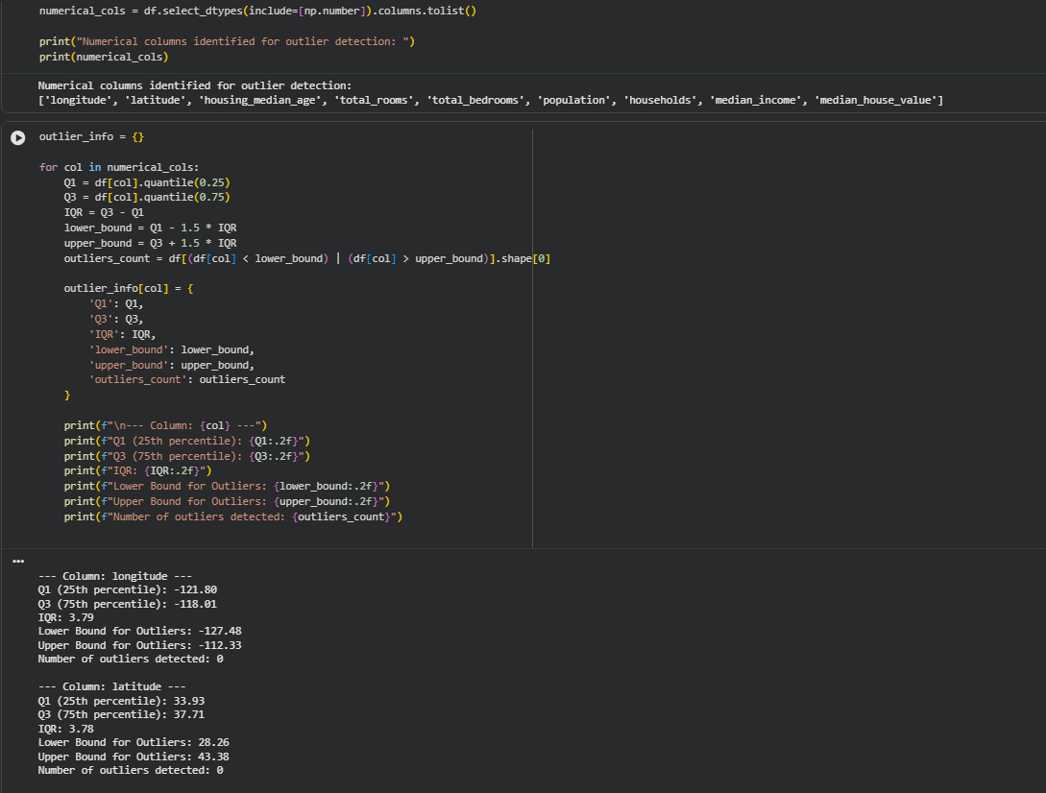

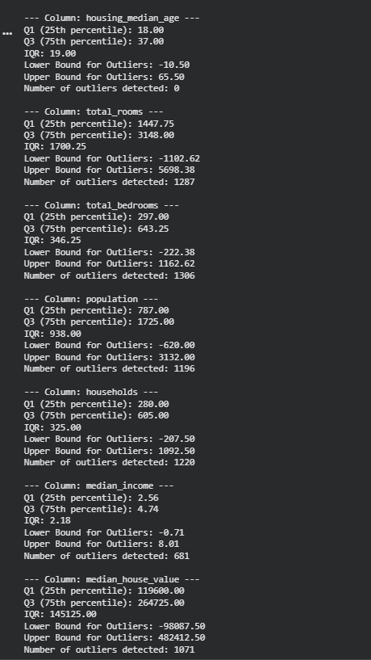

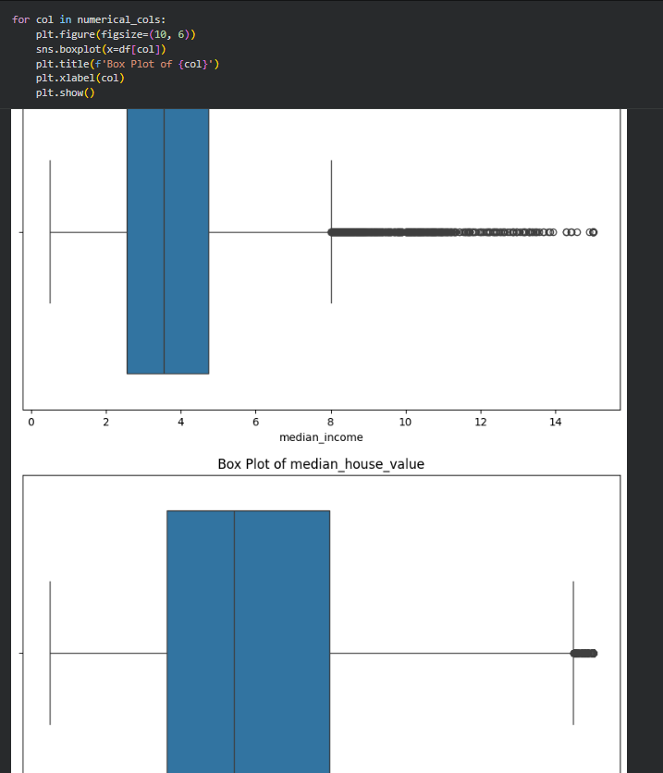

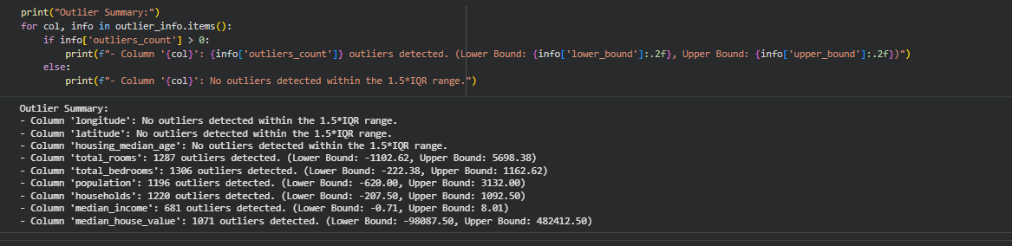

3. Binning and One-Hot Coding
Binning is a common data pre-processing technique used to transform continuous numerical data into discrete categories or bins.
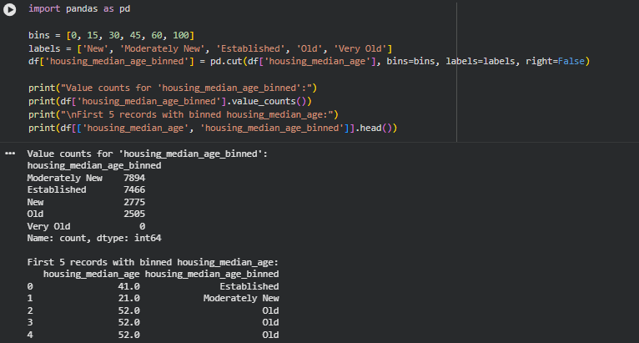
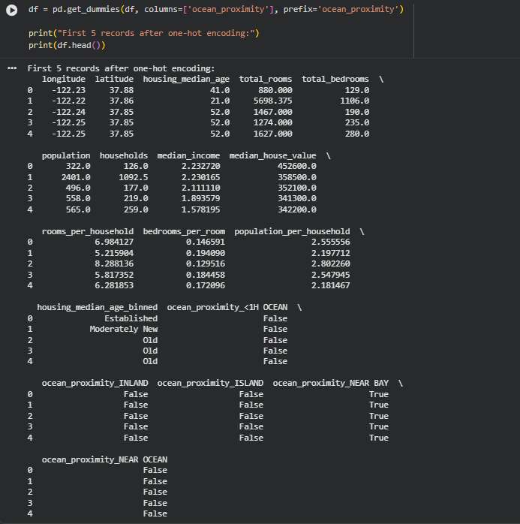

4. Log Transform
We first load our dataset into a Pandas DataFrame using the read_csv function. Then, we perform a log transformation on the ‘Price’ column using the log function from the numpy library. Finally, we print the first few rows of the transformed dataset using the head method.
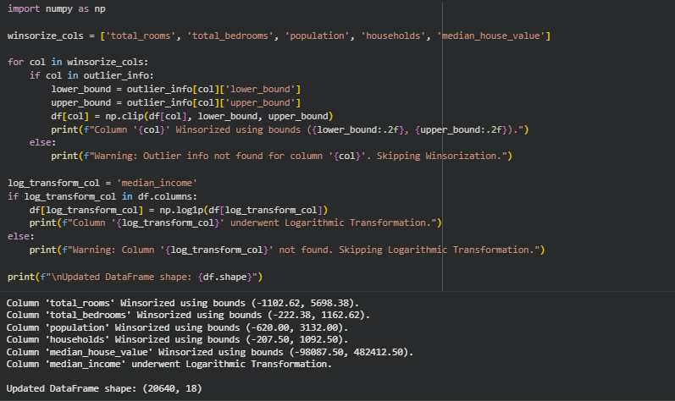
5. Grouping Operations:
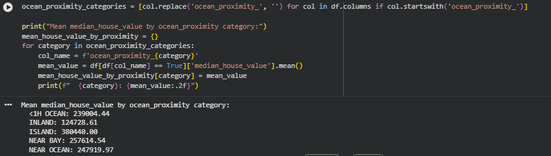

6. Feature Split
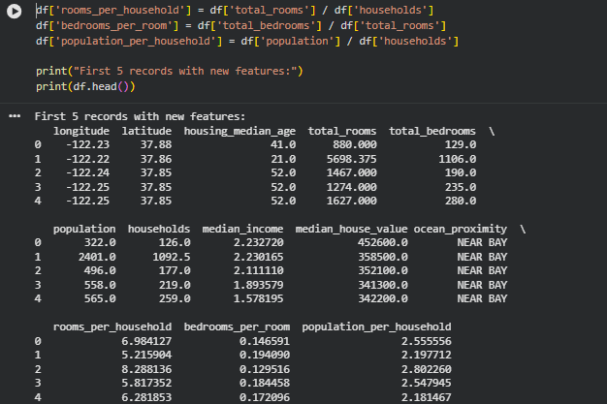

7. Scaling
First load the 'housing.csv' dataset using pd.read_csv(). Then, we initialize a MinMaxScaler object and select the columns to scale. Then fit and transform the selected columns using the fit_transform() method of the scaler and update the dataset with the scaled values. Finally, printed the head of the scaled dataset using
print(df.head()).

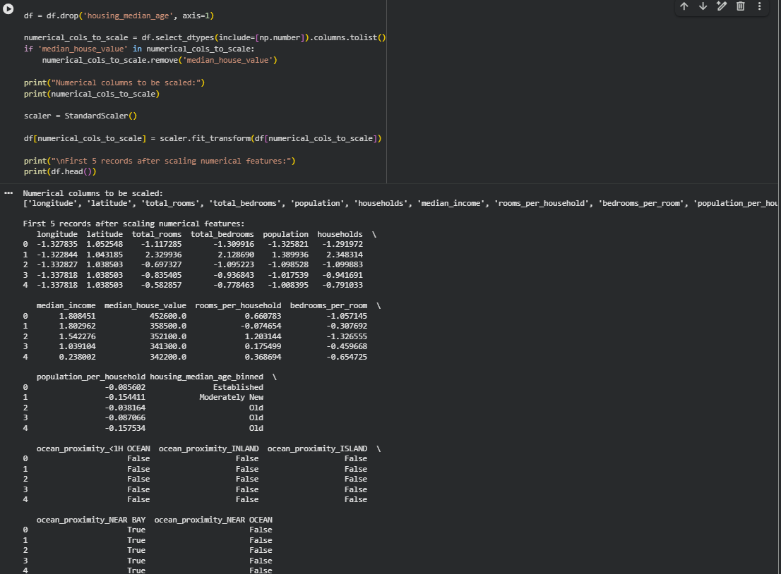

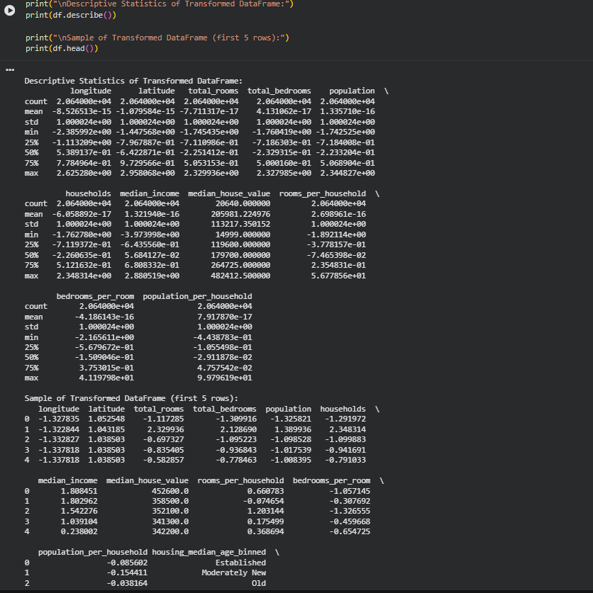

Conclusion:
This experiment successfully demonstrated the importance of data preprocessing and feature engineering as a foundational step in the machine learning pipeline. Using the California Housing dataset, various preprocessing techniques were applied to convert raw, real-world data into a structured and model-ready form. Missing values were handled using imputation to prevent data loss and ensure numerical stability. Outlier handling techniques were discussed to reduce skew and improve model robustness. Binning and log transformation helped simplify complex numerical distributions and reduce the impact of extreme values. One-hot encoding enabled categorical variables to be represented numerically without introducing false ordinal relationships. Grouping operations and feature splitting created more informative features by extracting meaningful patterns from existing data. Finally, feature scaling standardized numerical ranges, ensuring fair contribution of all features during model training.

Post lab Questions:
Explain following text Pre-processing techniques with example:
  - Tokenization
Tokenization is the process of breaking raw text into smaller units called tokens, which are usually words, sentences, or characters. It is the first and most essential step in text preprocessing because machine learning models cannot directly understand continuous text strings. By tokenizing text, we convert human language into manageable pieces that can later be transformed into numerical features. For example, the sentence “Machine learning is powerful” when tokenized at the word level becomes [“Machine”, “learning”, “is”, “powerful”]. Tokenization helps models analyze text patterns, word frequencies, and relationships between words in tasks such as sentiment analysis, text classification, and information retrieval.
  - Stemming
Stemming is a preprocessing technique used to reduce words to their root or base form by removing suffixes using simple rules. The goal of stemming is to group together different forms of the same word so they are treated as a single feature by the model. For example, the words “playing”, “played”, and “plays” are all reduced to the stem “play”. This reduces vocabulary size and improves computational efficiency. However, stemming can sometimes produce words that are not grammatically correct, such as converting “studies” to “studi”. Despite this limitation, stemming is widely used in applications where speed is more important than linguistic accuracy, such as search engines.
  - Lemmatization
Lemmatization is a more advanced preprocessing technique that converts words into their base or dictionary form, known as a lemma, by considering grammatical rules and context. Unlike stemming, lemmatization always produces valid and meaningful words. For example, “running” becomes “run”, “better” becomes “good”, and “studies” becomes “study”. Because it understands parts of speech, lemmatization preserves the semantic meaning of words more accurately. This makes it especially useful in natural language processing tasks where language understanding and correctness are important, such as chatbots, question answering systems, and text summarization.

